**RANDOM SCAN**

* If the voltage steering the beam change at a constant rate, the beam will trace a straight line, visible to a viewer. This technique is known as random scan. The beam can be moved randomly from any position to any other. Hence any primitive lines, characters and such can be represented by a sequence of lines.
* Vector displays or random displays can, at best, only simulate filled areas with closely spaced sequences of parallel lines.
* Refresh process is dependent on the complexity of the image i.e. vector display flicker when the number of primitives in the buffer becomes too large.
* Vector system can draw a continuous, smooth line from any point on the CRT face to any other.
* Refresh buffer stores the computer produced display list that contains point and line plotting commands with end points.

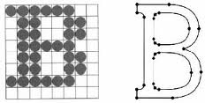

**RASTER SCAN**

* The complete image on a raster display is formed from the raster, which is a set of horizontal raster lines, each a row of individual pixels .the raster is thus stored as a matrix of pixels representing the entire screen area .at each pixel, the beam’s intensity is set to reflect the pixel’s intensity.
* It is easier to display areas filled with solid colors or patterns by altering the pixel’s intensity.
* Refresh process is independent on the complexity of the image. Flicker does not increase with increase in number of primitives in the image.
* Raster system can display mathematically smooth lines, polygons, circles by approximating them with pixels on the raster grid.
* Refresh buffer stores the display primitives in terms of component pixels.

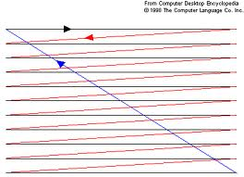

**SHADOW MASK CRT**

Color television sets and color raster displays use some form of shadow-mask CRT. Here, the inside of the tube’s viewing surface is covered with closely spaced groups of red, green and blue phosphor dots. The dot groups are so small that light emanating from the individual dots is perceived by the viewer as a mixture of the three colors. Thus, a wide range of colors can be produced by each group, depending on how strongly each individual phosphor dot is excited. A shadow mask, which is a thin metal plate perforated with many small holes and mounted close to the viewing surface, is carefully aligned so that each of the three electron beams can hit only one type of phosphor dot. The dots thus can be excited selectively.

A delta delta CRT is a common type of shadow mask CRT. The phosphor dots are arranged in a triangular triad pattern, as are the three electron guns. The guns are deflected together, and are aimed at the same point on the viewing surface. The shadow mask has one small hole for each triad. The holes are precisely aligned w.r.t both the trails and the electron guns, so that each dot in the trail is exposed to electrons from only one gun. High precision delta-delta CRT’s are particularly difficult to keep in alignment.

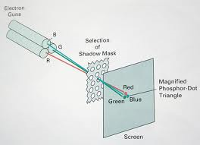

**Character generation and its methods**

Characters are almost always built into the graphics display device, usually as hardware but sometimes though software. There are 2 primary methods for character generation. One is called the stroke method. This method creates character out of a series of line segment, like strokes of a pen. We could build our own stroke method character generator by calls to the VECGEN algorithm. We would decide what line segments are needed for each character and set up the calls to the VECGEN for each character we wished to draw. In actual graphics displays, the commands for drawing the character line segment may be in either hardware or software. The stroke method lends itself to change of scale, the character may be made twice as large by simply doubling the length of each segment.

The second method of character generation is the dot matrix or bitmap method. In this scheme, characters are represented by an array of dots. An array of 5 dots wide and 7 dots high is often used but 7*9 and 9*13 arrays are also found. High-resolution devices, such as ink-jet or laser prints, may use character array is like a small frame buffer, just big enough to hold a character. The dots are the pixels for this small array. Placing the character on the screen then becomes a matter of copying pixel values from the small character array into some portion of the dot-matrix array is often a hardware device called a character generation chip but random access memory may also be used when many fonts are desired. The size of a dot is fixed, so the dot –matrix method does not lend itself to variable sized character.